Name: SANKALP VERMA

User Assignment – 3

Problem Statement :

1. Find the number of employees in the customer table.

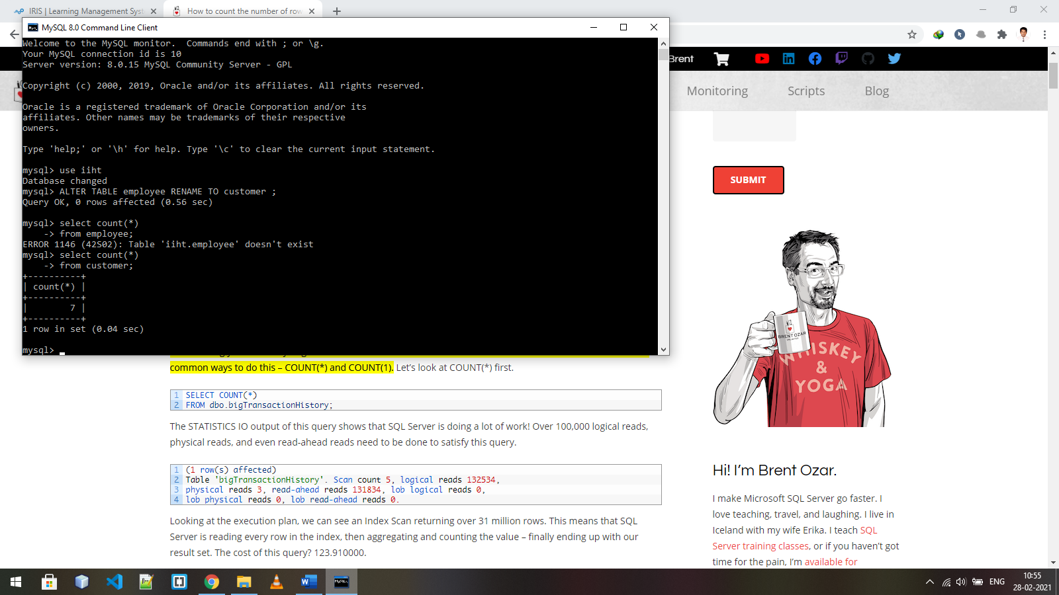

2. Find the number of employees in the department 20.

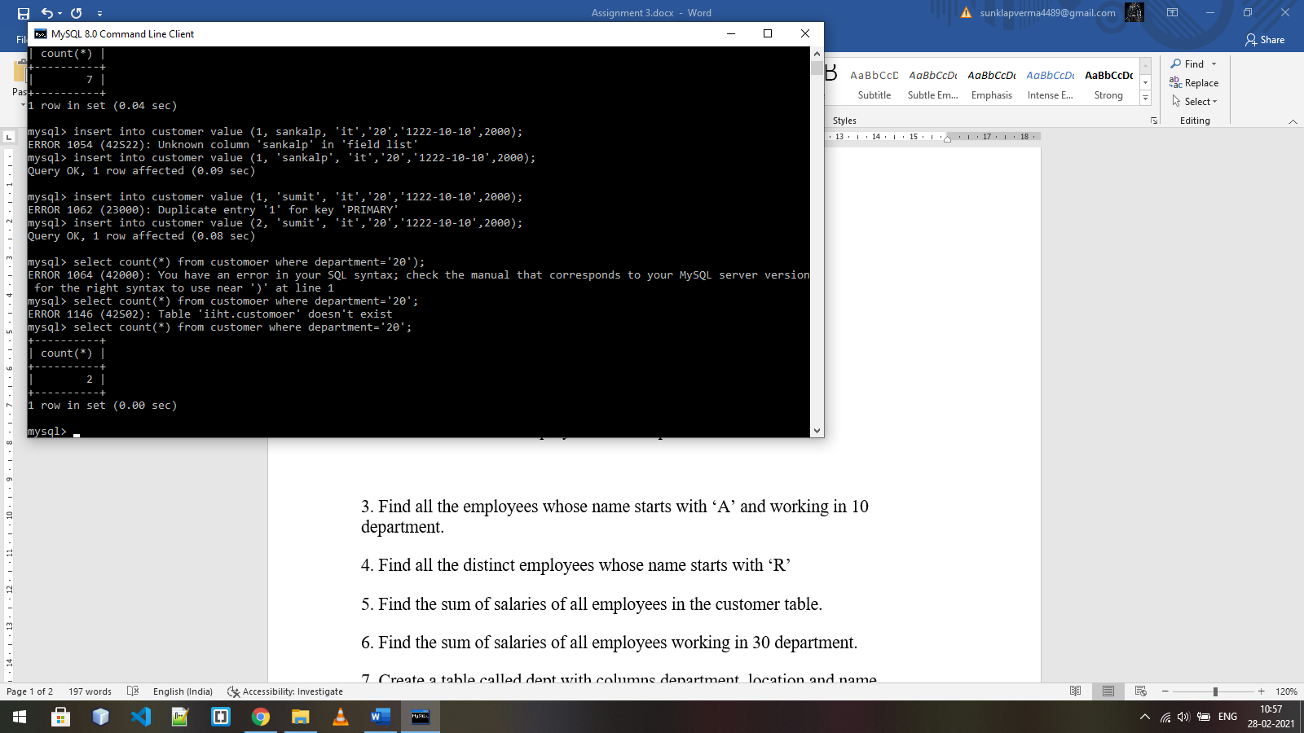

3. Find all the employees whose name starts with ‘A’ and working in 10 department.

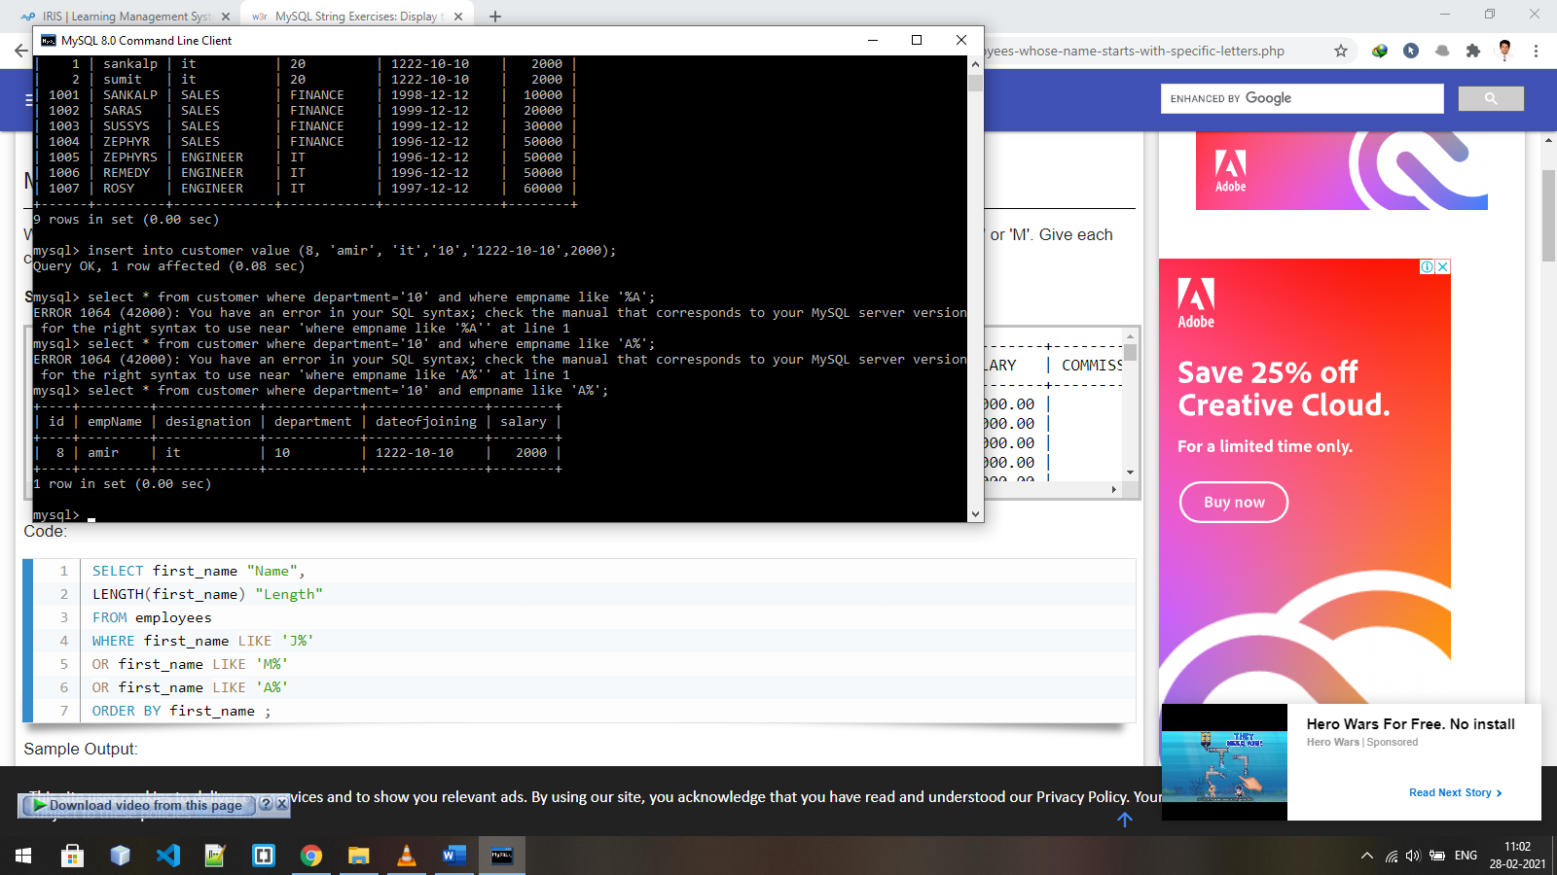

4. Find all the distinct employees whose name starts with ‘R’

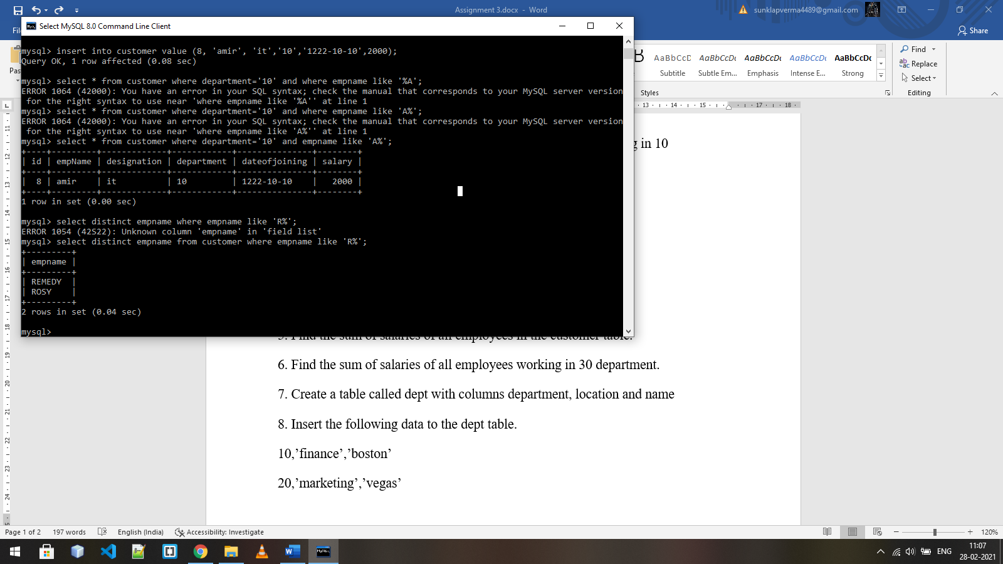

5. Find the sum of salaries of all employees in the customer table.

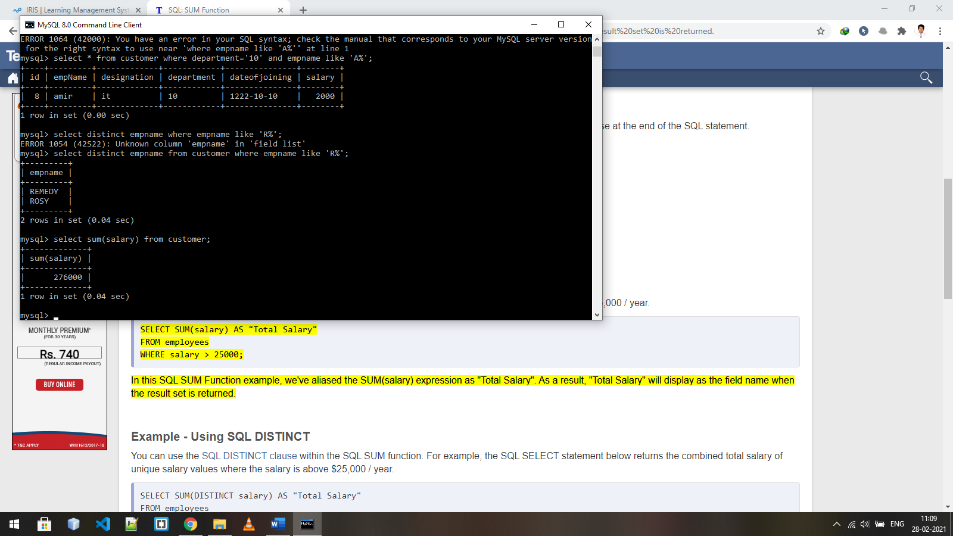

6. Find the sum of salaries of all employees working in 30 department.

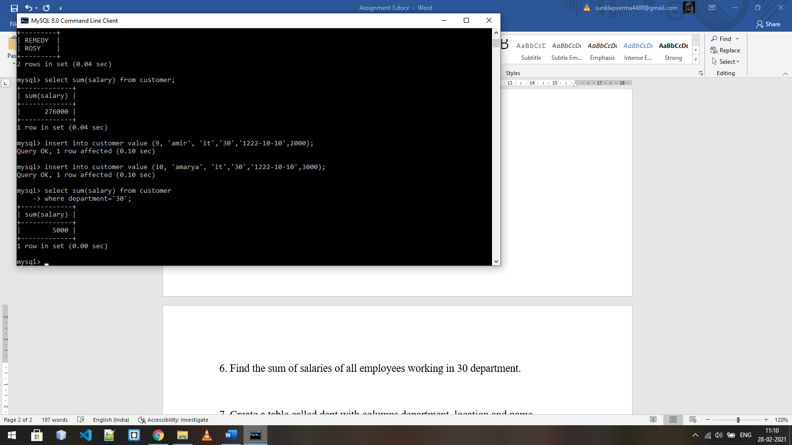

7. Create a table called dept with columns department, location and name

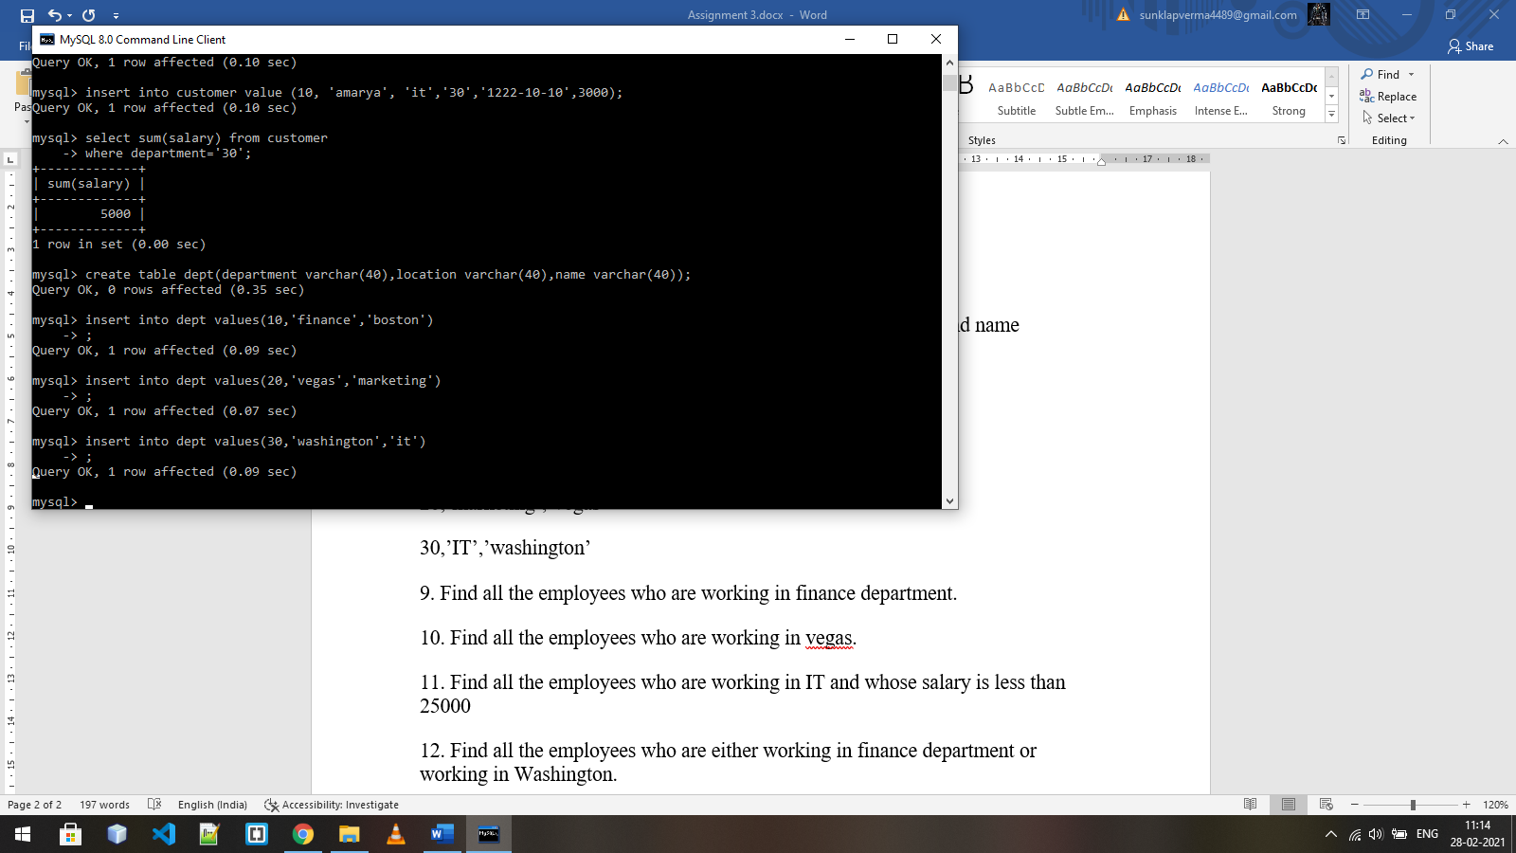

8. Insert the following data to the dept table.

10,’finance’,’boston’

20,’marketing’,’vegas’

30,’IT’,’washington’



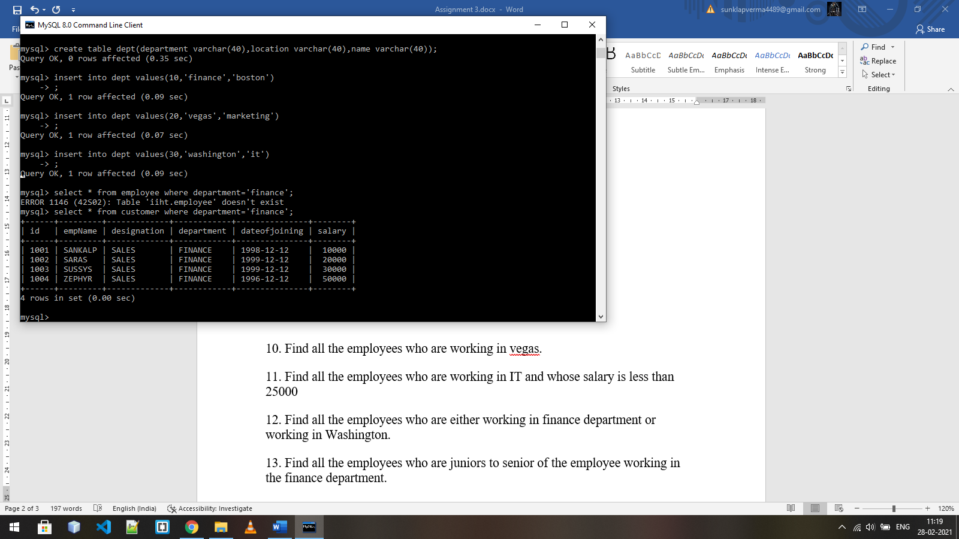9. Find all the employees who are working in finance department.

10. Find all the employees who are working in vegas.

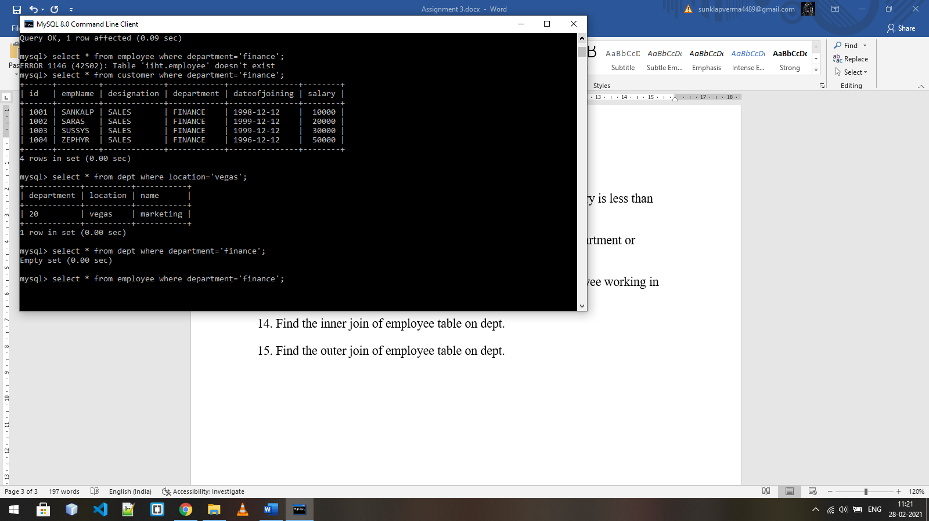

11. Find all the employees who are working in IT and whose salary is less than 25000

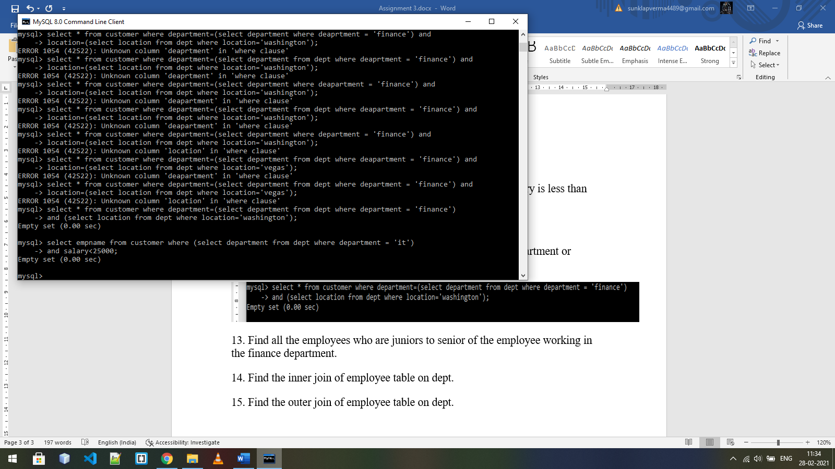

12. Find all the employees who are either working in finance department or working in Washington.

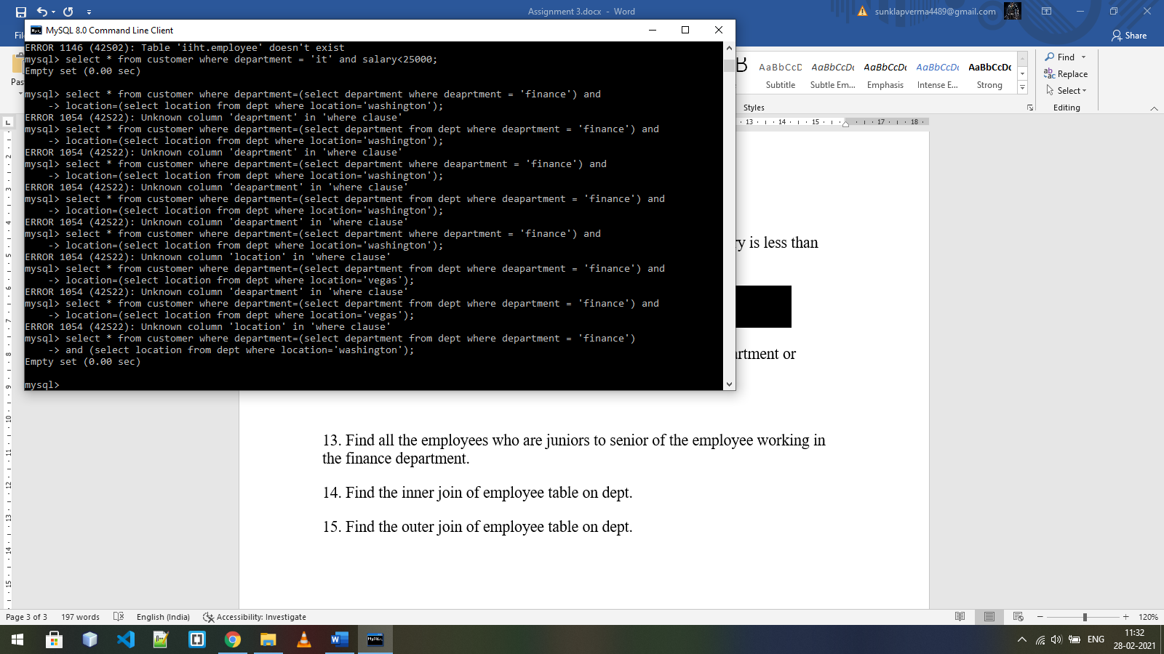

13. Find all the employees who are juniors to senior of the employee working in the finance department.

Ans: here I am taking Id for measuring seniority less id =more senior

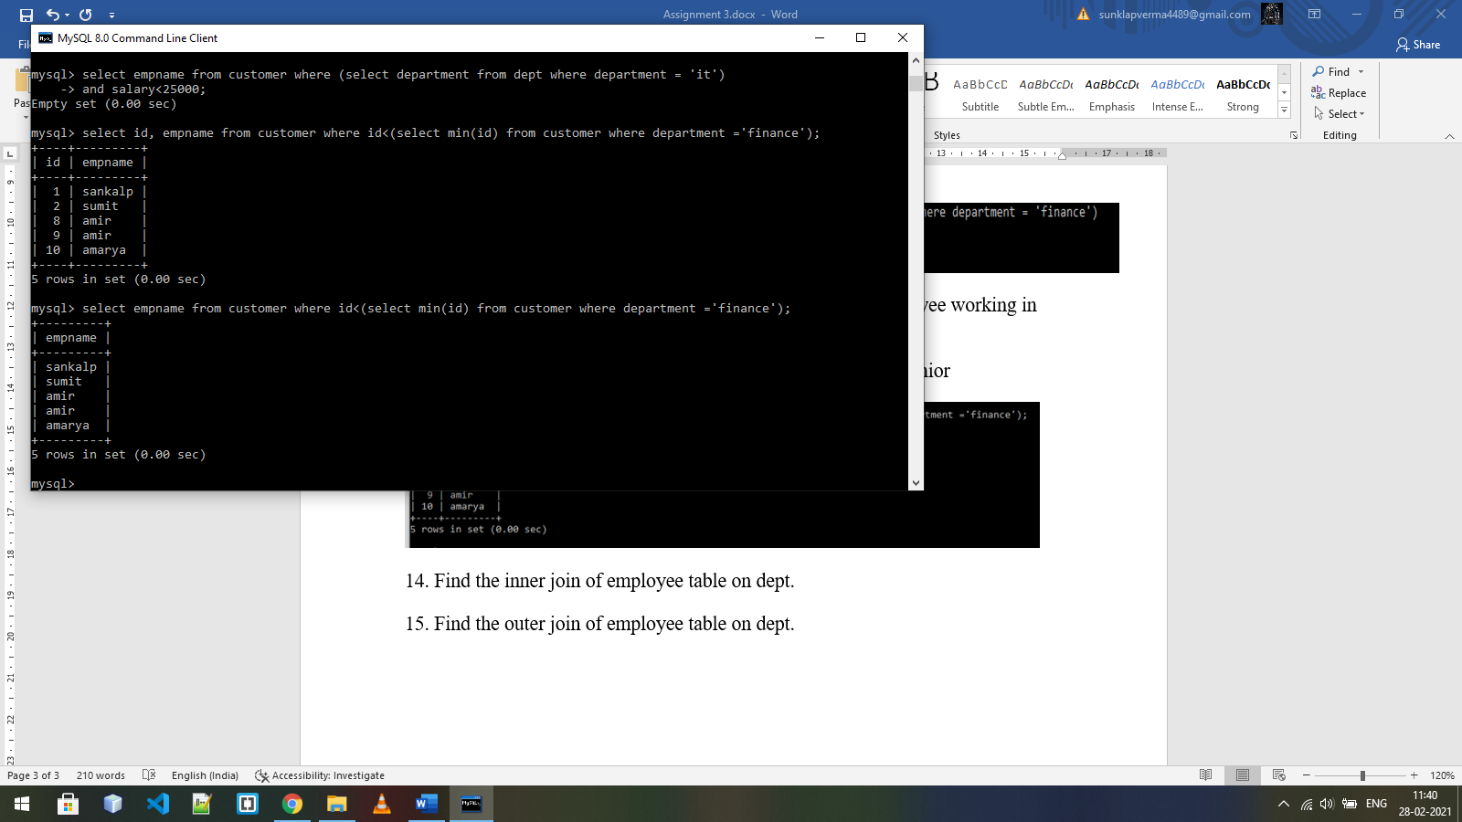

14. Find the inner join of employee table on dept.

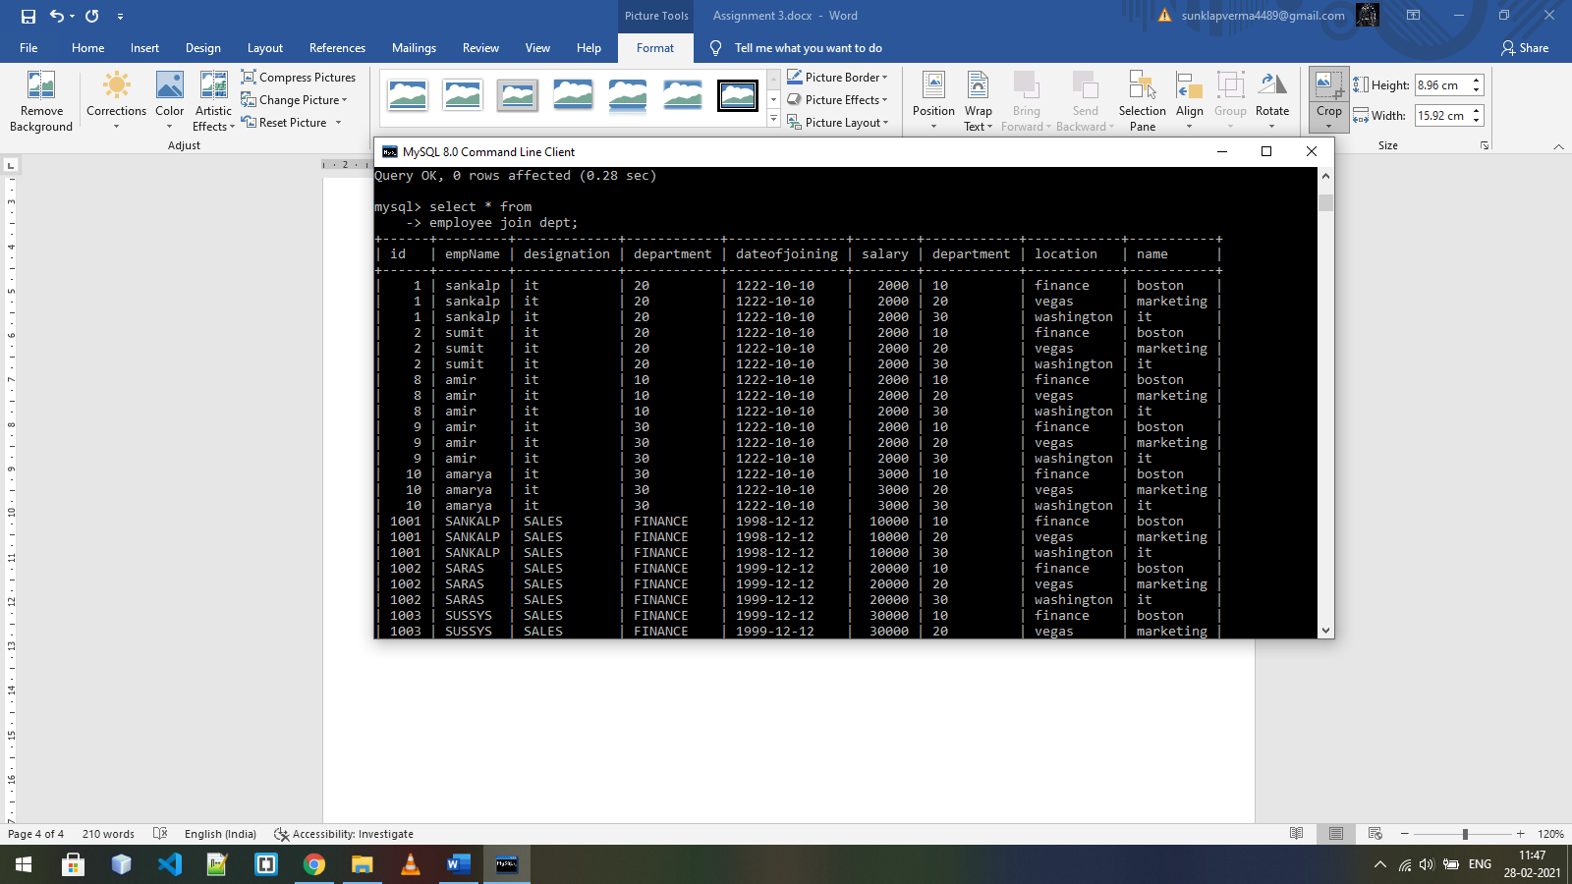15. Find the outer join of employee table on dept.

